word instruction

this is my new para

this is my another new para

this is my third new para***this is my new block***

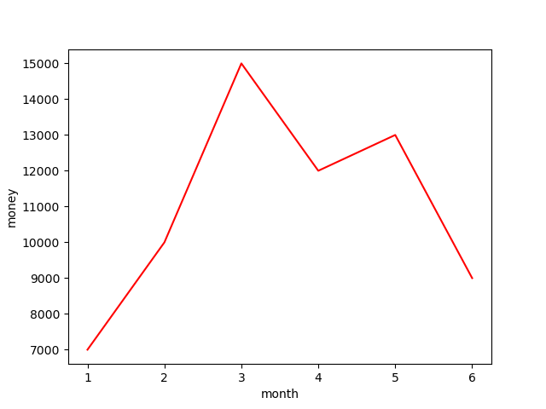

|  |  |  |
| --- | --- | --- |
| number | name | age |
| 1 | 张三 | 22 |
| 2 | 李四 | 21 |
| 3 | 王五 | 23 |